

**MS806 – Business Application Programming**

**Student Name: Jayakarthi Boovendran**

**NUI Galway ID Number: 19230487**

**Assignment:** 1

**Date of Submission:** **27/09/2019**

**Assignment I: Login Portal for MS806 – Business Application Programming**

**Screenshots of Application at Runtime:**

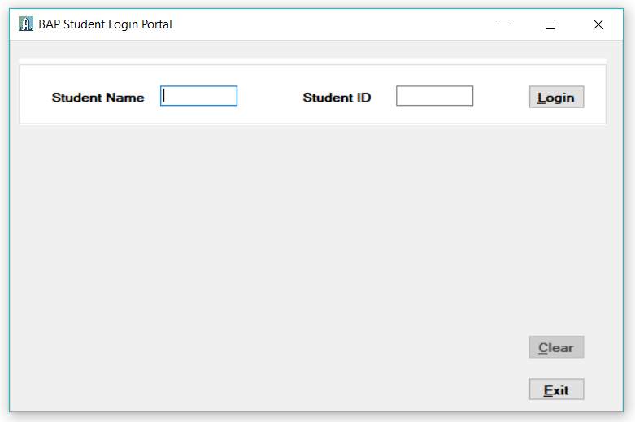

**Fig 1 : BAP Student Login Page**

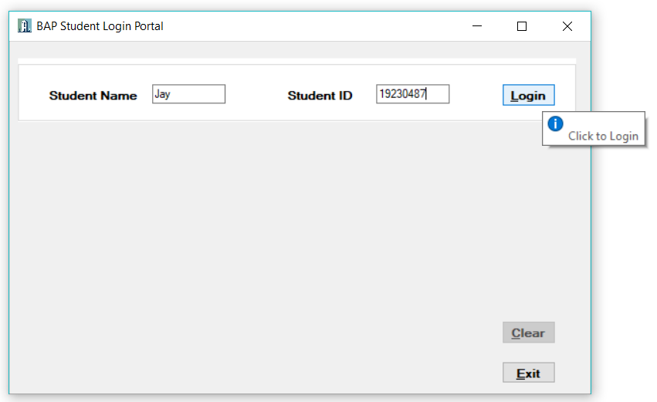

**Fig 2: Login page with Student credentials entered**

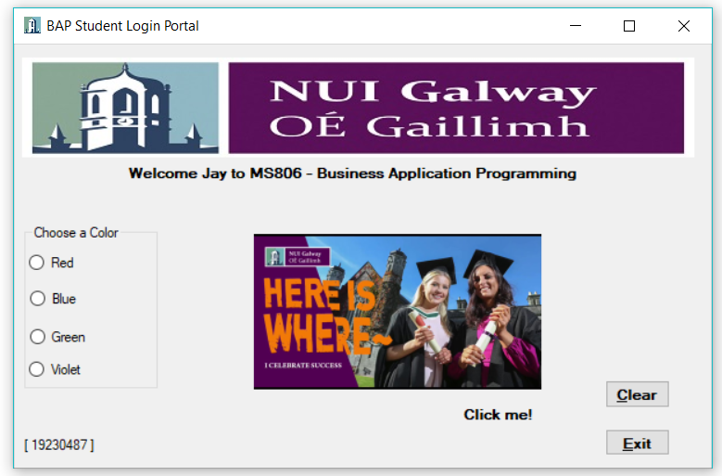

**Fig 3: On click of ‘Login’ user is redirected to next screen**

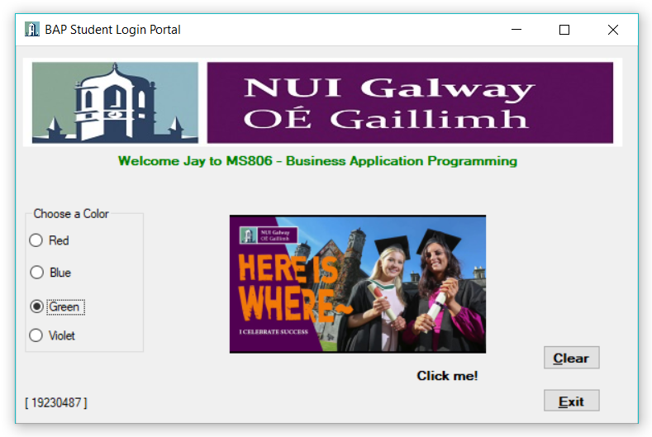

**Fig 4: Screen when, ‘Green’ is selected from the color panel**

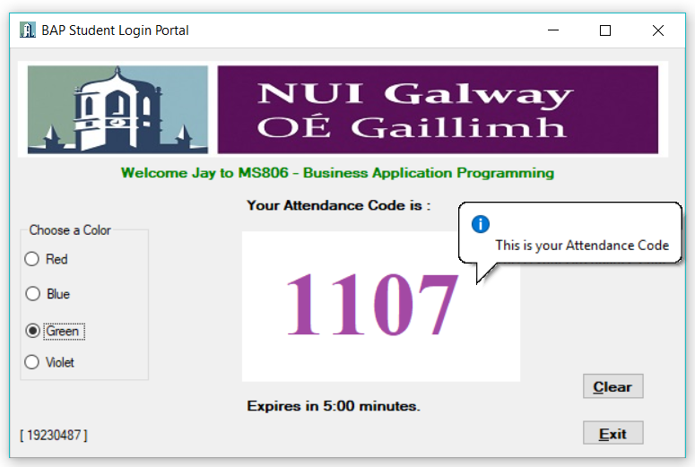

**Fig 5: On click of ‘Display Picture’, user is given a code**

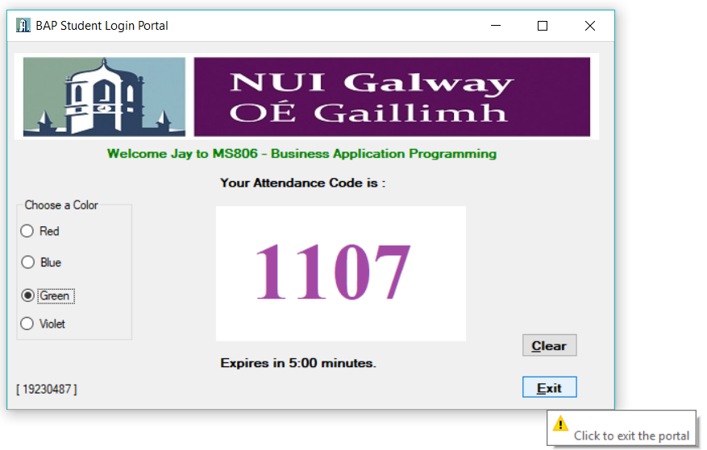

**Fig 6: Screen showing ‘Exit’ Button and its tooltip message**

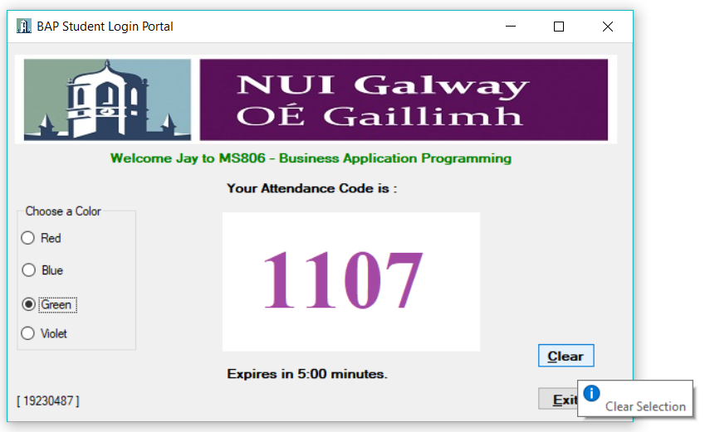

**Fig 7: Screen showing ‘Clear’ Button and its tooltip message**



**Fig 8: Screen when ‘Clear’ Button is clicked**

**Source Code:**

//# Student Name: Jayakarthi Boovendran

//# Student ID: 19230487

//# Date: 27/09/2019

//# Assignment No: 1

using System;

using System.Drawing;

using System.Windows.Forms;

namespace StudentLoginForm

{

public partial class StudentLoginForm : Form

{

string StudentID = string.Empty;

string StudentName = string.Empty;

string WelcomeString = "Welcome ";

string CourseCode = " to MS806 - Business Application Programming";

public StudentLoginForm()

{

InitializeComponent();

InitializeLoginPage();

}

//Initializes the Login Page on Form load

public void InitializeLoginPage()

{

LoginPortalGroupBox.Visible = true;

StudentNameInput.Text = string.Empty;

StudentIDInput.Text = string.Empty;

StudentID = string.Empty;

StudentName = string.Empty;

ClearButton.Visible = true;

ClearButton.Enabled = false;

ExitButton.Visible = true;

ExitButton.Enabled = true;

WelcomeMessageLabel.Visible = false;

WelcomeMessageLabel.Text = string.Empty;

WelcomeMessageLabel.ForeColor = Color.Black;

ColorPanel.Visible = false;

IDPanel.Visible = false;

IDPanel.Text = string.Empty;

DisplayPicture.Visible = false;

DisplayTooltip.Active = false;

ClickMeLabel.Visible = false;

AttendanceMessageLabel.Visible = false;

ExpireLabel.Visible = false;

ImageHeader.Visible = false;

StudentNameInput.Focus();

}

// # Login functionality

private void LoginButton_Click(object sender, EventArgs e)

{

//Saves User Credentials

StudentName = StudentNameInput.Text;

StudentID = StudentIDInput.Text;

LoginPortalGroupBox.Visible = false;

//Redirects to Next Page ('Course Page')

LoginRedirect();

}

// # Login Redirect Handling - Redirects to next page on successfull login

public void LoginRedirect()

{

WelcomeMessageLabel.Text = WelcomeString + StudentName + CourseCode;

WelcomeMessageLabel.Visible = true;

ColorPanel.Visible = true;

RedRadioButton.Checked = false;

BlueRadioButton.Checked = false;

GreenRadioButton.Checked = false;

VioletRadioButton.Checked = false;

IDPanel.Visible = true;

IDPanel.Text = "[ " + StudentID + " ]";

DisplayPicture.Visible = true;

DisplayPicture.Image = Properties.Resources.NUIG2;

ClickMeLabel.Visible = true;

DisplayTooltip.Active = false;

AttendanceMessageLabel.Visible = false;

ExpireLabel.Visible = false;

ImageHeader.Visible = true;

ClearButton.Enabled = true;

}

// # Color Panel Event Handling

private void RedRadioButton_CheckedChanged(object sender, EventArgs e)

{

WelcomeMessageLabel.ForeColor = Color.Red;

}

private void BlueRadioButton_CheckedChanged(object sender, EventArgs e)

{

WelcomeMessageLabel.ForeColor = Color.Blue;

}

private void GreenRadioButton_CheckedChanged(object sender, EventArgs e)

{

WelcomeMessageLabel.ForeColor = Color.Green;

}

private void VioletRadioButton_CheckedChanged(object sender, EventArgs e)

{

WelcomeMessageLabel.ForeColor = Color.Violet;

}

// # Display Picture Click Event Handling

private void DisplayPicture_Click(object sender, EventArgs e)

{

if (ClickMeLabel.Visible)

{

// Displays Picture2 on click of Picture1

DisplayPicture.Image = Properties.Resources.Code;

DisplayPicture.BackgroundImageLayout = ImageLayout.Stretch;

ClickMeLabel.Visible = false;

DisplayTooltip.Active = true;

AttendanceMessageLabel.Visible = true;

ExpireLabel.Visible = true;

}

else

{

// Displays Picture1 on click of Picture 2

DisplayPicture.Image = Properties.Resources.NUIG2;

DisplayPicture.BackgroundImageLayout = ImageLayout.Stretch;

ClickMeLabel.Visible = true;

DisplayTooltip.Active = false;

AttendanceMessageLabel.Visible = false;

ExpireLabel.Visible = false;

}

}

// # Clear Button Event Handling - Initializes the Login Page to its Initial state

private void ClearButton_Click(object sender, EventArgs e)

{

InitializeLoginPage();

}

// # Exit Button Event Handling - Closes the Application

private void ExitButton_Click(object sender, EventArgs e)

{

Close();

}

}

}